What are Functions?
Functions are defined procedures; you give them a name, and they contain a set of instructions. Instead of writing the same steps over and over, you can just call the function.
Example:
DEFINE line3 {
FORWARD
MARK
FORWARD
MARK
FORWARD
MARK
}
CALL line3
Command Bank
FORWARD | move 1 square in the direction robot is facing
LEFT | turn left (90°)
RIGHT | turn right (90°)
MARK | mark the current square (pretend robot “draws” there)
REPEAT n TIMES { … } | repeat instructions
DEFINE functionName { … } | create a new function
CALL functionName | use a function you defined

Robot Grid (5 × 5)
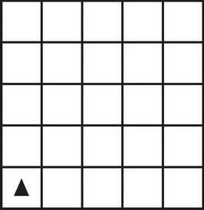
1. Write a function for a short vertical line. Define a function called line3 that marks 3 squares straight up.


2. Use your function. After defining line3, call it twice in a row. What shape does that make?

3. Make a square with a function. Define a function square that draws a 2 × 2 square. Then call it once.
4. Bonus Challenge: Create a function called letterL that draws an L-shape.
Remember: Functions save time because you can define once, and call many times!

